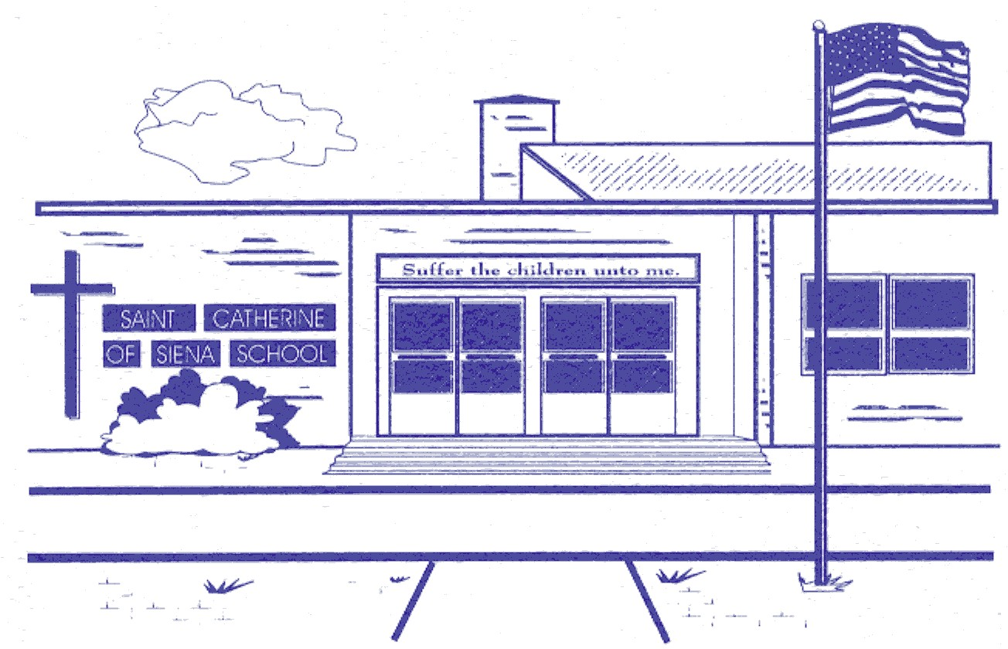
ST. CATHERINE OF SIENA SCHOOL
Middle States Accredited
39 E. Bradford Avenue, Cedar Grove, NJ 07009
Telephone 973-239-6968 Fax 973-239-1008
www.scs-school-cedargrovenj.org

Basketball Registration

Athlete’s Name: ____________________________________________ Grade ________

Birthdate _______________

Address ________________________________________________ Phone # _____________________

Mother: _______________________________ Father: __________________________________

Parent E-mail address ___________________________________ Cell # ________________________

Emergency Information

Name and phone number of 2 reliable people who are available if necessary:

1. _____________________________________________ Tel. #____________________________

2. ______________________________________________ Tel. # ___________________________

Family Physician and Telephone Number:
___________________________________________ ________________________

List any allergy or condition the coaches need to be aware of:
_________________________________________________________________________________

_________________________________________________________________________________

The coaching staff has my permission to apply ice to a contusion and a bandage to an abrasion as
needed: Yes ______ No ______

I give permission for my child to join the SCS Basketball Program and have read the Athletic Program Guidelines, Mission Statement, Code of Conduct, and Sudden Cardiac Death in Young Athletes pamphlet. Included is my registration fee of $60.00 made payable to St. Catherine of Siena.

Parent Signature ____________________________________________________________________

* Release: St. Catherine of Siena School is not liable for injuries beyond what is covered by our insurance.

